Introduction
In architecture, Neoclassicism signaled a return to order and rationality after the melodramatic, flamboyant Baroque, and the decorative frivolity of the Rococo. As a style composed of many elements, based to a varying extent on the antique forms of Greek architecture and Roman architecture, neoclassical architecture can be imitated to a greater or lesser extent. For this reason, building designers have continued to borrow from Greek and Roman models ever since the mid-17th century - since the fall of Rome in the fifth centur Which makes neoclassicism the world's most popular style of building.
Early Neoclassical Architecture (1640-1750)
The earliest forms of neoclassical architecture grew up alongside the Baroque, and functioned as a sort of corrective to the latter's flamboyance. This is particularly evident in England, where examples of early neoclassicism include buildings like St Paul's Cathedral, the Royal Observatory in Greenwich, and the Royal Chelsea Hospital, all designed by Sir Christopher Wren (1632-1723) who is still labelled as a Baroque architect. Other early English Neoclassicist architects included William Kent (1685-1748), who designed Chiswick House and the Royal Mews, Chairing Cross; and Robert Adam (1728-92), who designed Syon House, Bowood House, and the Theatre Royal London. At the same time, the Renaissance architecture of the Italian Andrea Palladio (1508-80) were repopularised and a new Palladiums spread throughout Europe and America.
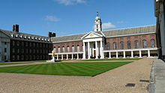
the Royal Chelsea Hospital

Features of Neoclassical Architecture (1750-1850)
Used in a variety of image-related construction programs - by feudal monarchies, enlightened democracies, totalitarian regimes and worldwide empires - Neoclassicism was yet another return to the Classical Orders of Greek and Roman Antiquity on a monumental level, albeit with the retention of all the engineering advances and new materials of the modern era. It was marked by large-scale structures, supported and/or decorated by columns of Doric, Ionic or Corinthian pillars, surmounted by enlarged Renaissance-style domes. Sometimes columns were multiplied and stacked, to create an impression of height, while facades were decorated with a combination of colonnades, rotundas and porticoes.

Neoclassical Architecture in France
Neoclassicism was born in Italy, although it became especially active in France largely because of the presence of French designers trained at the French Academy in Rome. Classical features had begun appearing in architectural design at the end of Louis XVI's reign. This style was then adopted during the first Napoleonic empire: High Society employed it on their private homes, along with extras like faux ruins, follies, grottos and fountains to decorate the landscape, while more experimental architects used it to design a range of civic structures. Among the most celebrated French architects were: Jacques GermainSoufflot (1713-80), who designed the Parisian Pantheon - a key highlight of the Grand Tour - Claude Nicolas Ledoux (1736-1806), who designed the Cathedral of Saint-Germaine, the Hotel Montmorency, the Royal Salt works at Arc-et-Senans, and the Chateau de Booneville; and Jean Chalgrin (1739-1811), who designed the Arc de Triumph.
the Cathedral of Saint-Germaine
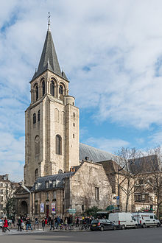

Neoclassical Architecture in Britain
Thus in Britain, which had never really taken to the Baroque, the Neoclassical style was employed in the design of a wide variety of public buildings from banks to museums to post offices, while British Royalty commissioned one of Britain's greatest architects, the Regency neoclassicist John Nash(1752-1835), to redesign entire city blocks and parks. Aristocratic landowners embraced the style, refurbishing their country mansions with new porticos and columns. English neoclassical architects included: John Nash (1752-1835), who designed Buckingham Palace, Cumberland Terrace and Carlton Terrace in London; Sir John Soane (1753-1837), who designed the Bank of England, Pitshanger Manor and the Dulwich Picture Gallery; and Sir Robert Smirke (1780-1867), designer of the British Museum, the General Post Office, Covent Garden Theatre and Eastnor Castle.
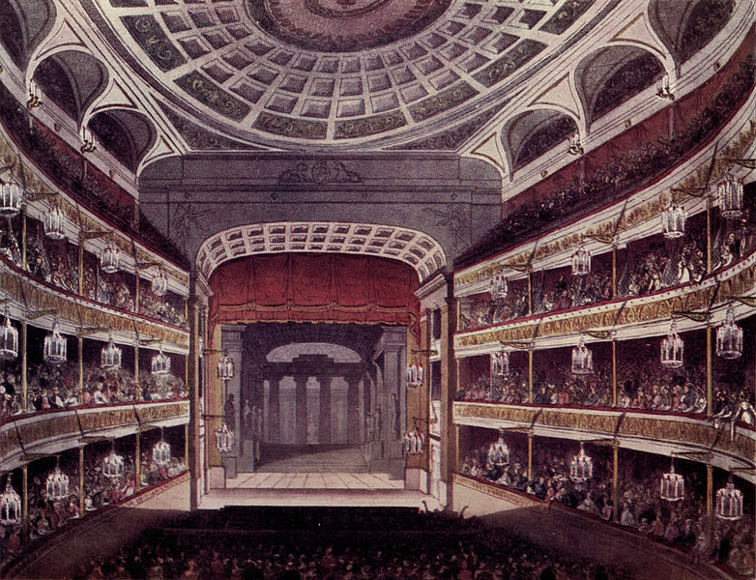
Covent Garden Theatre

Neoclassical Architecture in Germany
In Germany, inspired by the books of Johann Joachim Winckelmann (1717-68) and supported by the royal patronage of Friedrich Wilhelm II, the architects Karl Friedrich Schinkel (1781-1841) and Carl Gotthard Langhans (1732-1808) turned Berlin into a classical gem to rival Paris and Rome. Langhans was responsible for the Brandenburg Gate, a monumental construction of pillars and columns based on the Propylaea on the Acropolis in Athens, while Schinkel (1781-1841) designed the Konzerthaus on Gendarmenmarkt (1818-21), the Tegel Palace (1821-4), and the Altes Museum (1823-30). The foundation and praxis of applied art at the Bauakademie (Berlin Design Academy) further encouraged Neoclassicism in Germany. See also German Art, 19th Century.
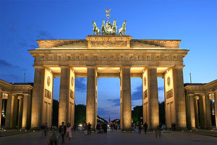
Brandenburg Gate

American Neoclassicism
Despite the popularity of the neoclassical style in Europe, it was in the New World of America where Neoclassical architecture found its true home. Early American architects who used neoclassical designs included Thomas Jefferson (1743-1826), who designed the Virginia State Capitol and Monticello; William Thornton (1759-1828) who, along with Benjamin Latrobe (1764-1820) and Charles Bulfinch (1863-1844), designed the US Capitol Building (1793-1829) in Washington DC. It was during the 19th century, that the newly formed United States began building civic buildings, including universities, and in the process began to define the aesthetics of the nation. See also: American Architecture (1600-present).
The United States Capitol Building, for instance, with its neoclassical facade and dome, remains one of America's most recognizable and iconic structures. Begun in 1793, according to a plan by William Thornton, the building - inspired by the Louvre and the Pantheon in Paris - is centered on a grand entrance, supported by projecting wings that ground the structure horizontally. The centre projects outward and upward, accentuated by vertical columns that draw the eye up to the dome. The dome and rotunda were initially made of wood, but were later rebuilt with stone and cast-iron. Other architects involved in the building, include Benjamin Henry Latrobe (1764-1820), Stephen Hallet and Charles Bulfinch.
The United States Capitol Building,
The United States Capitol Building,
Latrobe himself went on to design a number of other buildings in the Neoclassical style including: the Bank of Pennsylvania, Richmond Capitol, the Baltimore Exchange, the Fairmount Waterworks in Philadelphia, the Baltimore Basilica and the Louisiana State Bank to name but a few. Another famous American architect who built in the clear geomtry of the neoclassical style, was Thomas Jefferson (1743-1826), the third President of the United States. He designed the Virginia State Capitol, the Rotunda at the University of Virginia, and Monticello House, where he died on July 4, 1826.

Interior design

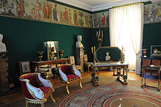
Château de Malmaison, 1800, room for the Empress Joséphine, on the cusp between Directories’ style and Empire style
Indoors, neoclassicism made a discovery of the genuine classic interior, inspired by the rediscoveries at Pompeii and Herculaneum. These had begun in the late 1740s, but only achieved a wide audience in the 1760s, with the first luxurious volumes of tightly controlled distribution of Le Antichità di Ercolano (The Antiquities of Herculaneum). The antiquities of Herculaneum showed that even the most classicizing interiors of the Baroque, or the most "Roman" rooms of William Kent were based on basilica and temple exterior architecture turned outside in, hence their often bombastic appearance to modern eyes: pedimented window frames turned into gilded mirrors, fireplaces topped with temple fronts.
The new interiors sought to recreate an authentically Roman and genuinely interior vocabulary. Techniques employed in the style included flatter, lighter motifs, sculpted in low frieze-like relief or painted in monotones encamaïeu ("like cameos"), isolated medallions or vases or busts or bucrania or other motifs, suspended on swags of laurel or ribbon, with slender arabesques against backgrounds, perhaps, of "Pompeiian red" or pale tints, or stone colors. The style in France was initially a Parisian style, the Goûtgrec ("Greek style"), not a court style; when Louis XVI acceded to the throne in 1774, Marie Antoinette, his fashion-loving Queen, brought the "Louis XVI" style to court.
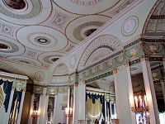
Interior of Home House in London, designed by Robert Adam in 1777 in the Adam style.
However there was no real attempt to employ the basic forms of Roman furniture until around the turn of the century, and furniture-makers were more likely to borrow from ancient architecture, just as silversmiths were more likely to take from ancient pottery and stone-carving than metalwork: "Designers and craftsmen ... seem to have taken an almost perverse pleasure in transferring motifs from one medium to another"
A new phase in neoclassical design was inaugurated by Robert and James Adam, who travelled in Italy and Dalmatia in the 1750s, observing the ruins of the classical world. On their return to Britain, they published a book entitled The Works in Architecture in installments between 1773 and 1779. This book of engraved designs made the Adam repertory available throughout Europe. The Adam brothers aimed to simplify the rococo and baroque styles which had been fashionable in the preceding decades, to bring what they felt to be a lighter and more elegant feel to Georgian houses. The Works in Architecture illustrated the main buildings the Adam brothers had worked on and crucially documented the interiors, furniture and fittings, designed by the Adams.

Characteristics
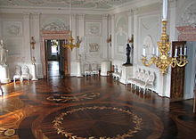
A. Rinaldi. The White hall of the Gatchina palace. 1760s. An early example of the Italianate neoclassical interior design in Russian architecture.
High neoclassicism was an international movement. Though neoclassical architecture employed the same classical vocabulary as Late Baroque architecture, it tended to emphasize its planar qualities, rather than sculptural volumes.Projections and recessions and their effects of light and shade were more flat; sculptural bas-reliefs were flatterand tended to be enflamed in friezes, tablets or panels. Its clearly articulated individual features were isolated rather than interpenetrating, autonomous and complete in themselves.
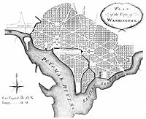
The L'Enfant Plan for Washington, D.C., as revised by Andrew Ellicott in 1792.
Neoclassicism also influenced city planning; the ancient Romans had used a consolidated scheme for city planning for both defense and civil convenience, however, the roots of this scheme go back to even older civilizations. At its most basic, the grid system of streets, a central forum with city services, two main slightly wider boulevards, and the occasional diagonal street were characteristic of the very logical and orderly Roman design. Ancient facades and building layouts were oriented to these city design patterns and they tended to work in proportion with the importance of public buildings.
Many of these urban planning patterns found their way into the first modern planned cities of the 18th century. Exceptional examples include Karlsruhe and Washington DC. Not all planned cities and planned neighborhoods are designed on neoclassical principles, however. Opposing models may be found in Modernist designs exemplified by Brasilia, the Garden city movement, levittowns, and new urbanism.

